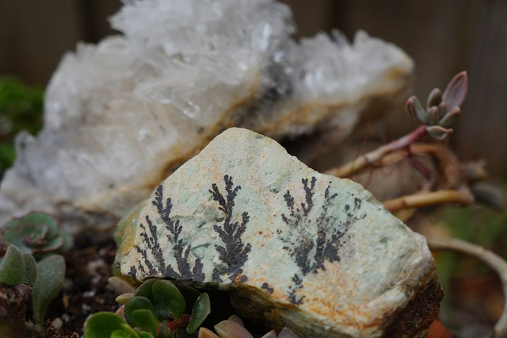

2019

***Natural Path***

***in this issue >>>***

***current topics >>>***

Some babies experience Reiki for the first time in a hospital’s neonatal ICU, as a way to reduce the stress associated with pain, sickness,

thrive and weight gain problems as the fussy babies shake off stress, sleep better, and become calmer, happier, more healthy babies.

Simply watching a baby relax under the touch of Reiki can soothe the entire family. Babies are extraordinarily perceptive of parental stress and respond positively when they see their parents relax! Once you have a relaxed, happy, healthy infant, the whole family benefits!

and the constant drone of respirators, IVs, and other medical equipment. Reiki is especially helpful for preemies, especially those that are on life support or are too fragile to be held. Reiki can help these tiniest patients relax, improving their ability to cope with the

Babies can benefit greatly from Reiki treatments, and so do their families. There is a feeling of helplessness when there is a sick baby crying at home or in the ICU. Reiki comforts babies to reduce crying and fussing in a way that quiets the house and calms distraught parents.

Babies are, in a sense, beautiful blank canvases that are receptive to energy therapy.

***the***

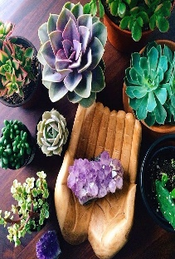

**JUNE**

*Reiki for Infants and Babies*

*Radiant Pregnancy with Reiki*

*Reiki and Healthy Living*

*Yoga Poses to Ease Pregnancy Pain*

stress of being hospitalized for the first few precious days of life.

**Reiki can help:**

* Babies sleep longer, more restfully
* Soothe a baby with colic
* Ease teething pain
* Hasten recovery from a cold

Reiki may also assist in reversing failure to

*Every newborn is unique and special in their own way. Even after just a week of life, some babies can show early signs of stress, such as colic or fussiness. While infant stress may seem harmless initially, continuous anxiety at such a young age may create disharmony and imbalances that can negatively affect your growing bundle of joy!*

*Benefits of Reiki for Infants and Babies!*

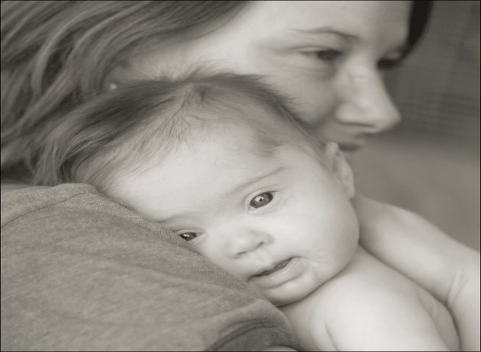

*Reiki for Infants and Babies*

Babies are open to energy flow, so deprogramming sessions are rarely necessary. Unlike adults and older children conditioned to fear or reject innovative approaches to healing, infants have not developed the emotional defenses that can block Reiki. They are, in a sense, beautiful blank canvases that are receptive to energy therapy. Because of this openness, a short Reiki session is all most babies need – 10 to 20 minutes, depending on the baby’s needs.

*Babies are Receptive to Energy Therapy*

**An Insight into Naturopathic methods**

While Reiki’s effects vary from person to person, most pregnant women who receive Reiki report feeling more relaxed, balanced, and radiant after treatments. Reiki can also help you let go of any fears, anxieties, or negative

***healing advice >>>***

*5 Ways Reiki is Part of Healthy Living*

*More Radiant Pregnancy with Reiki Healing*

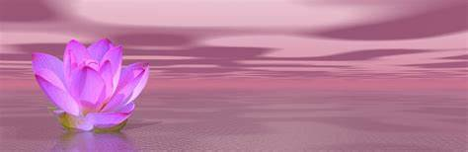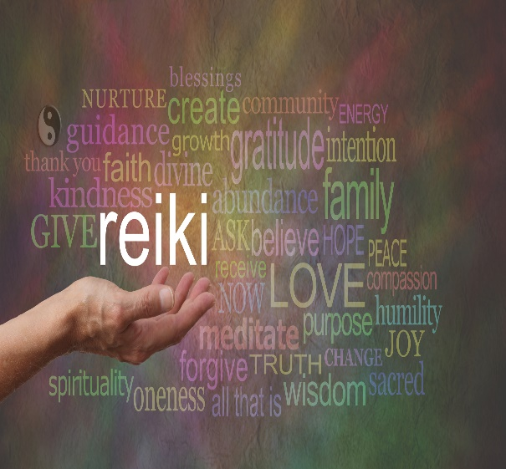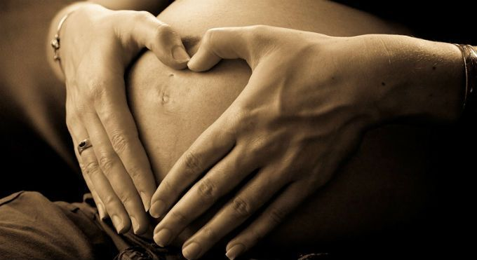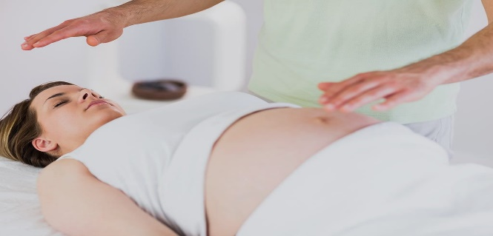

1. **Relieves Stress.** A healthy life has minimal stress. This negative element causes dozens of medical problems such as hypertension, cardiac issues, and kidney disease.
2. **Improves Sleep.** A calm frame of mind is important for a good night’s sleep. The result is improved mental alertness and fewer aches and pains.
3. **Creates a Positive Mental Outlook.** The soothing environment and gentle, non-invasive touch associated with Reiki sets the stage for a relaxing experience open to positive life possibilities. The darker side of problems like the loss of a job fade. Acknowledging alternatives becomes easier.
4. **Stimulates the Immune System.** The immune system is constantly under attack by allergies, cancers, infectious diseases, and other disorders. Reiki provides fresh supplies of vital life energy to boost immunity naturally and help maintain health.
5. **Fosters Living in the Present.** Reiki allows recipients to push aside looming things over which they have no control and focus on the present. This leads to creative problem solving.

The regular practice of Reiki is essential for optimal health.

***Reiki and healthy living are intertwined through these five Reiki attributes:***

Ask anyone who has ever heard about Reiki to use one phrase to describe it. Chances are, they’ll mention it’s a process to heal an existing condition that is a bit out of balance. This natural healing area has worldwide recipients who have experienced first-hand how it directs energy to the recipient to help restore balance and potentially assist in healing physical and emotional problems.

However, Reiki is also a tool for maintaining a healthy state once attained. Reiki and healthy living are inseparable when it comes to wellness.

***Why Reiki and Healthy Living are Inseparable***

If you’re worried that Reiki will be too strong during pregnancy, think again: Reiki is guided by gentle life force energy and your body intuitively understands its own energy needs**.** Your own body is in charge and takes it in as needed and where needed most.

But Reiki isn’t only healthy during pregnancy! It can also be used for everything from treating anxiety to easing labor, delivery, and recovery. And don’t forget; babies, toddlers, and kids love Reiki too!! This is an ancient art of healing that can be enjoyed by the whole family

feelings you may be experiencing during your pregnancy.

Even better? Your baby will also enjoy the soothing benefits of this complementary therapy which is passed from you to your unborn child during the session.

**Reclined Bound Angle Pose (Supta Baddha Konasana)**

This pose increases blood circulation in the lower abdomen, stretches the groin, and increases external rotation in the hips. It’s also my favorite way to calm down and relax my anxious mind.

Make sure to modify this posture for pregnancy by placing a bolster or two under your back and head to create an incline (so you are not flat on your back), and a block between feet to broaden your pelvis.

**Cat/Cow Pose (Marjaryasana Bitilasana)**

As the baby grows, more pressure is put on the spine, so moving on hands and knees relieves that pressure. Table Top position also encourages the baby into proper position for delivery and can provide relief during contractions in labor.

***ask the experts >>>***

***Daily Pregnancy Meditation Mantra***

*Q:*

*A:*

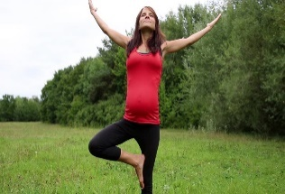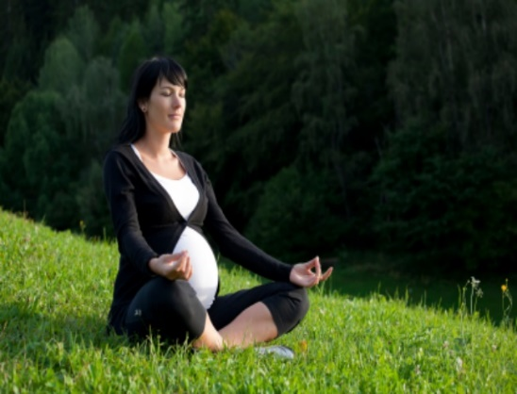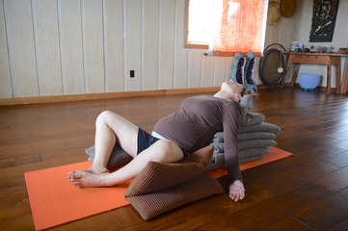

**I can go with the flow!**

Embarking on pregnancy is a lot like stepping into the ocean. You approach the mercurial water and slowly wade in, never sure when a wave will knock you down. Sometimes you’ll keep your head above water, swimming along with swift, sure strokes. Other times you’ll surrender, letting the waves wash over you. Give yourself to the powerful ebb and flow of nature and to the rhythms of your own body.

*Affirmation:*

Yoga helps you breathe and relax, which in turn can help you adjust to the physical demands of pregnancy, labor, birth, and motherhood. It calms both mind and body, providing the physical and emotional stress relief your body needs throughout pregnancy. Avoid Hot Yoga, poses that require you to be on your stomach, or poses that lie you flat on your back in later trimesters.

***Is Yoga Safe During Pregnancy?***

***Yes, with appropriate precautions!***

Creating life and carrying a soul inside your body for nine months gives new meaning to the word amazing. This almost makes you forget how uncomfortable it can be during pregnancy. Here are a couple of poses to help with the growing body inside!

*Yoga Poses to Ease Pregnancy Pains*

*Two things in the world that you never regret: a swim in the ocean, the birth of a child. – Mary Gordon*

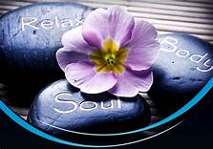

Discounts available for Seniors, Emergency Responders, Military, & Health Care Professionals!

Please make sure to inquire about my Client Rewards Program.

Gift Certificates available upon request for that special someone in your life!

Can’t get in store to get a treatment? Give me a call to set up a private appointment in your own home!

2827 N Dal Paso Ste 127

Hobbs NM 88240

with Eve

Infinite Healing

*Your health and well-being are of the utmost importance! Schedule your appointment today and take care of the mind, body, and soul!*

***thoughts...***

*final*

Contact me at **575-602-2203** infinitehealing.abmp.com